This is an excerpt from a first-year academic writing class, which is mandatory for all students at the institution.

Course Assignments
All assignment information will be posted in NEXUS. Assignments should be submitted through the ‘Assessments’ area in NEXUS. We will discuss all of the assignments when we meet in class.

Please note that course assignments and information may be subject to change over the course of the semester. If a change is required, the instructor will consult with the class and advise them of the proposed changes well in advance of any impacted deadlines.
Assignments
The assignments in the course align with the areas of focus described above.
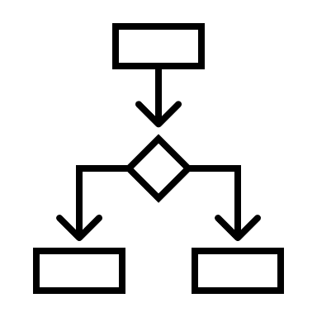
Choices in Writing: In the first four weeks of the course, we will be focusing on choices that writers make and demonstrating those choices in writing.
Assignment | Due Date | Grade Contribution
Paragraph Draft | September 9 | 5%
Paragraph Final | September 27 | 10%
Paragraph for an Alternate Audience | October 11 | 5%

Writing analysis: To address and demonstrate competency in writing analysis, you will do an in-depth analysis of an article. Part of this analysis will be completed through group discussion. The discussion will culminate in an individual summary and critique of the same article.
Assignment | Due Date | Grade Contribution
Writing Analysis – Groupwork (in class) | October 25, November 1, 8 | 15%
Writing Analysis – Individual Summary & Critique | November 25 | 15%

Argument Essay: You will write an essay that makes an argument and that uses strong supporting evidence (including sources). More information about this will be provided in class and on NEXUS.
Assignment | Due date | Grade Contribution
Argument Essay Proposal | October 18 | 10%
Argument Essay Outline | November 18 | 5%
Argument Essay Draft (optional - for feedback) | November 29 | (Not graded)
Argument Essay Final | December 13 | 20%

Course Engagement: Engagement with the course is essential for developing your writing and working toward the learning outcomes. Your engagement in the course can make a difference to your learning and development as a writer. The engagement grade is a significant portion of the final grade (a possible 15%) because it reflects the amount of work you put into the course and you can choose the amount of labour you are putting into this grade.
Assignment | Due date | Grade Contribution
Below is a chart that indicates the work that is required for the Course Engagement grade. For each grade, all of the requirements need to be met to receive the grade; if one is not met then the grade will be the next lower on the scale. | Various dates throughout the term | 15%

Course Engagement Grade Required Work (a possible 15% of the final grade)
If you would like to achieve... | Do the following | By this date
the full 15% | - Writing self-assessment and goals for the term (beginning of the term) AND Reflection on writing (end of the term)  - Complete the Plagiarism and Academic Integrity Learning Module (available in the NEXUS course site)  - Submit all assignments by the due date  - Attend at least 10 of 12 classes | Writing self-assessment and goals: September 11  Plagiarism and Academic Integrity Module: September 20  Reflection on Writing: December 6
10% | - Writing self-assessment and goals for the term (beginning of the term) OR Reflection on writing (end of the term)  - Complete the Plagiarism and Academic Integrity Learning Module (available in the NEXUS course site)  - Submit all assignments  - Attend at least 8 of 12 classes
5% | - Complete the plagiarism and Academic Integrity Learning Module (available in the NEXUS course site)  - Submit all assignments  - Attend at least 6 of 12 classes

